**CYCLE-3**

**Mathplotlib**

**Demonstrate creating various types of charts and plots using functions in mathplotlib library**

1. **Sarah bought a new car in 2001 for $24,000. The dollar value of her car changed each year as shown in the table below.**

**Value of Sarah's Car**

**Year Value**

**2001 $24,000**

**2002 $22,500**

**2003 $19,700**

**2004 $17,500**

**2005 $14,500**

**2006 $10,000**

**2007 $ 5,800**

**Represent the following information using a line graph with following style properties**

* **X- axis - Year**

**Y –axis - Car Value**

* **title –Value Depreciation (left Aligned)**
* **Line Style dashdot and Line-color should be red**
* **point using * symbol with green color and size 20**

**Subplot() provides multiple plots in one figure.**

**PROGRAM**

import matplotlib.pyplot as plt  
import numpy as np  
xpoints = np.array([2001, 2002,2003,2004,2005,2006,2007])  
ypoints = np.array([24000, 22500,19700,17500,14500,10000,5800])  
plt.plot(xpoints, ypoints, '*g',ms = 20)  
plt.plot(xpoints, ypoints, ':r')  
  
leg = plt.legend(title="Value Depreciation ")  
leg._legend_box.align = "left"  
plt.show()

**OUTPUT**

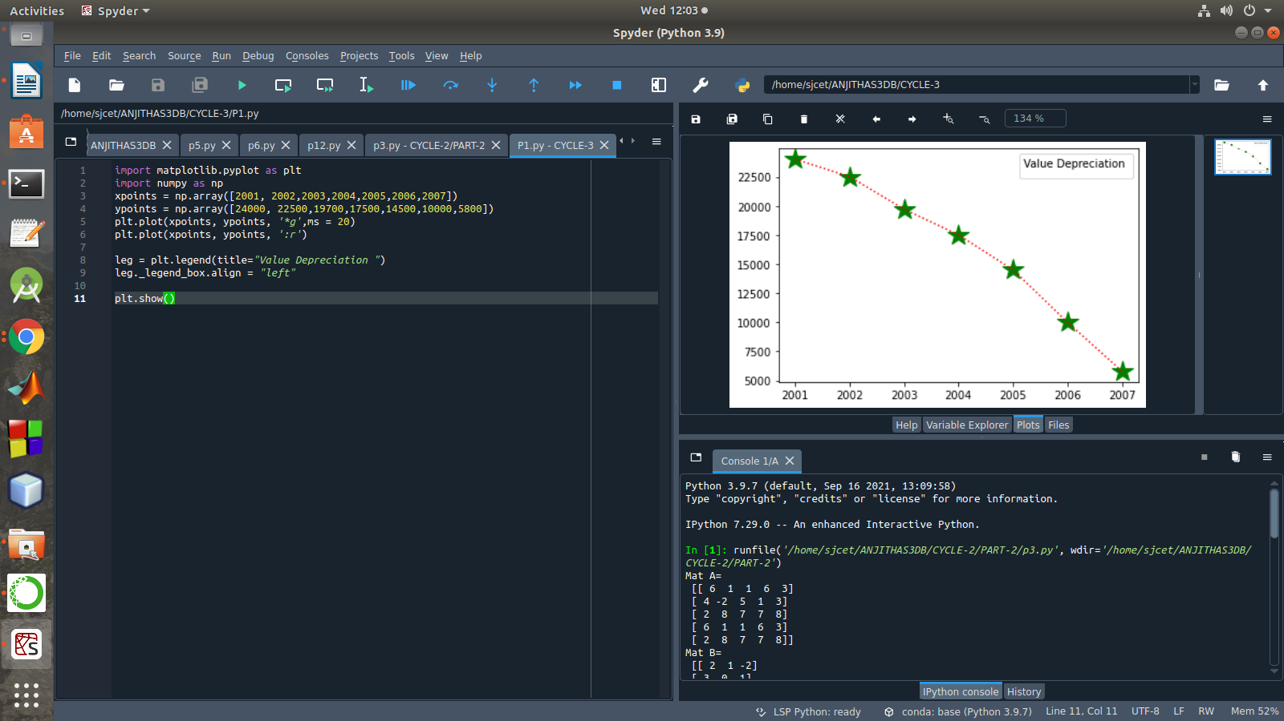

1. **Following table gives the daily sales of the following items in a shop**

|  |  |  |  |  |  |
| --- | --- | --- | --- | --- | --- |
| **Day** | **Mon** | **Tues** | **Wed** | **Thurs** | **Fri** |
| **Drinks** | **300** | **450** | **150** | **400** | **650** |
| **Food** | **400** | **500** | **350** | **300** | **500** |

**Use subplot function to draw the line graphs with grids(color as blue and line style dotted) for the above information as 2 separate graphs in two rows**

1. **Properties for the Graph 1:**

* **X label- Days of week**
* **Y label-Sale of Drinks**
* **Title-Sales Data1 (right aligned)**
* **Line –dotted with cyan color**
* **Points- hexagon shape with color magenta and outline black**

**PROGRAM**

**OUTPUT**

1. **Properties for the Graph 2:**

* **X label- Days of Week**
* **Y label-Sale of Food**
* **Title-Sales Data2 ( center aligned)**
* **Line –dashed with yellow color**
* **Points- diamond shape with color green and outline red**

**PROGRAM**

**OUTPUT**

1. **Create scatter plot for the below data:(use Scatter function)**

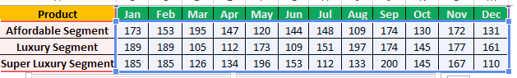

**Create scatter plot for each Segment with following properties within one graph**

* **X Label- Months of Year with font size 18**
* **Y-Label- Sales of Segments**
* **Title –Sales Data**
* **Color for Affordable segment- pink**
* **Color for Luxury Segment- Yellow**
* **Color for Super luxury segment-blue**

**PROGRAM**

**OUTPUT**

1. **Display the above data using multiline plot( 3 different lines in same graph)**

* **Display the description of the graph in upper right corner(use legend())**
* **Use different colors and line styles for 3 different lines**

**PROGRAM**

**OUTPUT**

1. **100 students were asked what their primary mode of transport for getting to school was. The results of this survey are recorded in the table below. Construct a bar graph representing this information.**

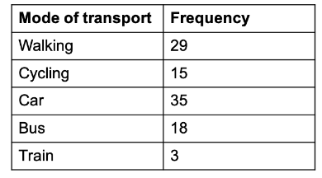

**Create a bar graph with**

* **X axis -mode of Transport and Y axis ‘frequency’**
* **Provide appropriate labels and title**
* **Width .1, color green**

**PROGRAM**

**OUTPUT**

1. **We are provided with the height of 30 cherry trees.**

**The height of the trees (in inches): 61, 63, 64, 66, 68, 69, 71, 71.5, 72, 72.5, 73, 73.5, 74, 74.5, 76, 76.2, 76.5, 77, 77.5, 78, 78.5, 79, 79.2, 80, 81, 82, 83, 84, 85, 87.Create a histogram with a bin size of 5**

**PROGRAM**

**OUTPUT**